# Speed Control Model

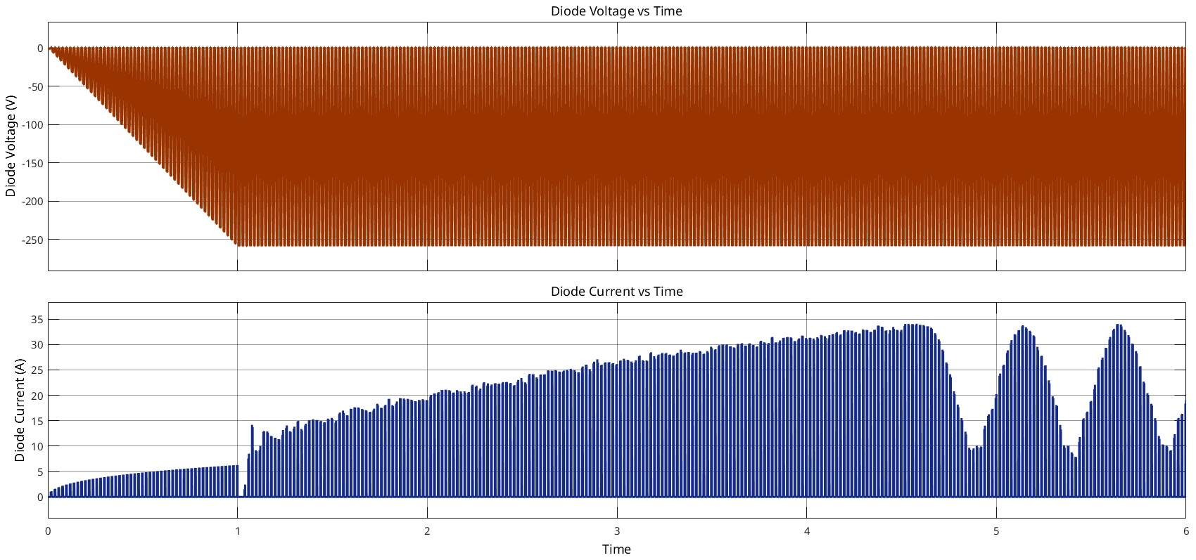

Figure x: Voltage and Current on the Diode

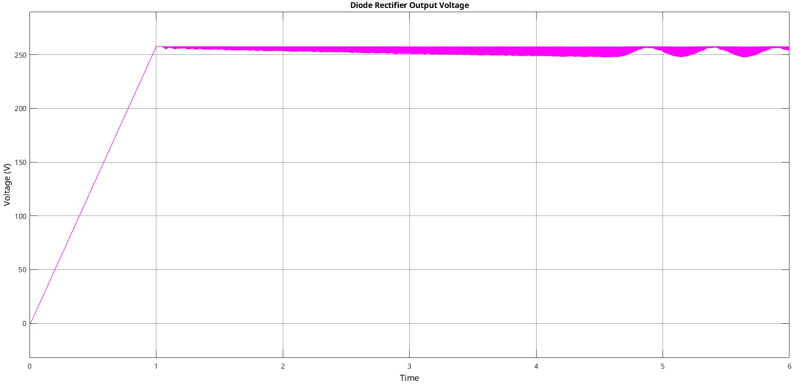

Figure x: Rectifier Output Voltage

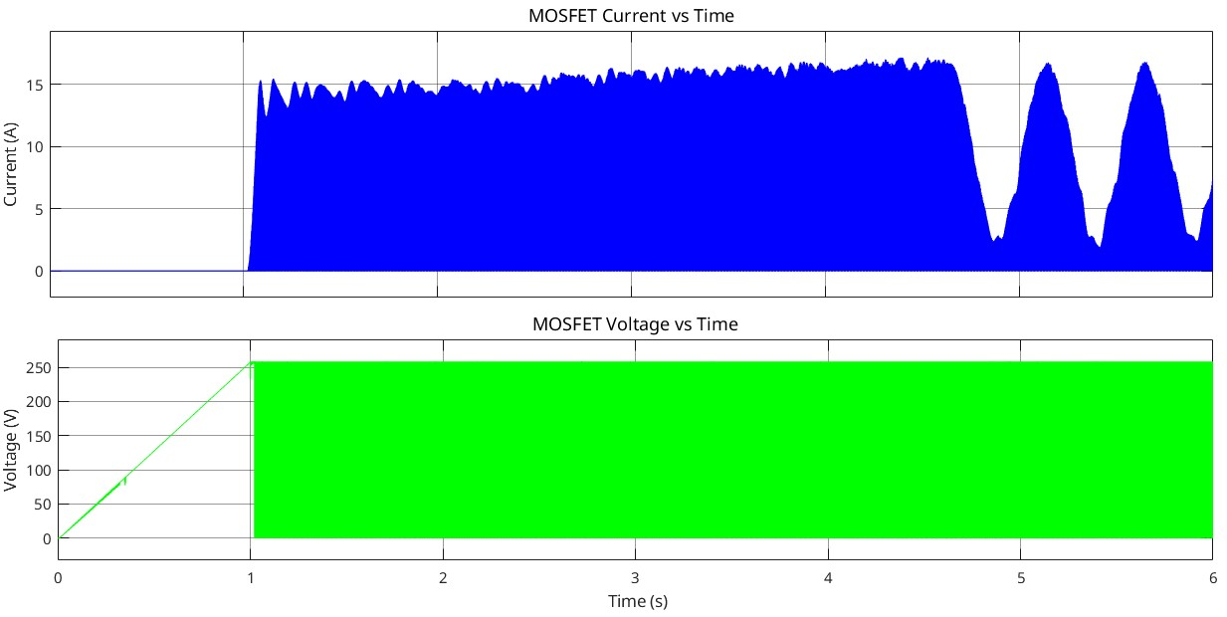

Figure x: Voltage and Current on the MOSFET

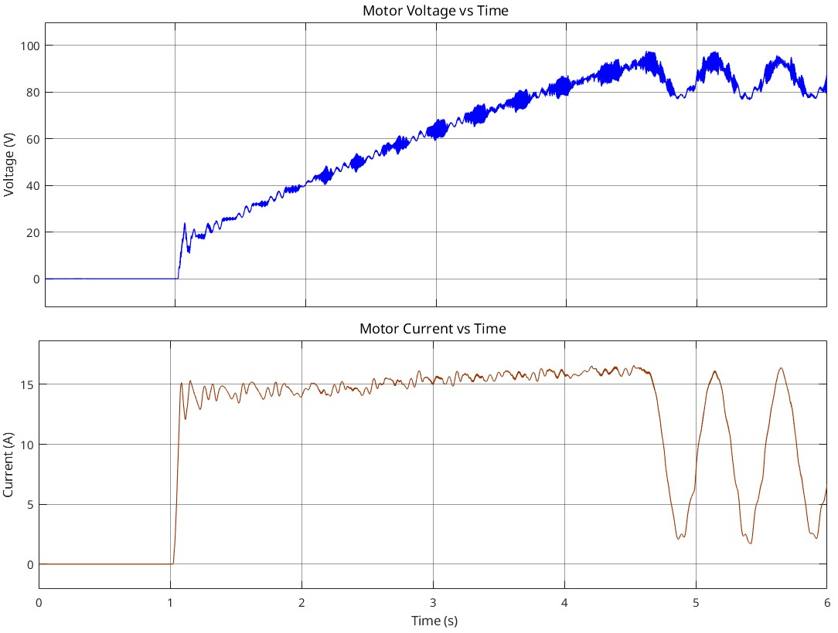

Figure x: Voltage and Current on the Motor

(ripples after the 4.5s is caused by speed oscillations around 150 rad/s speed controller should be optimized)

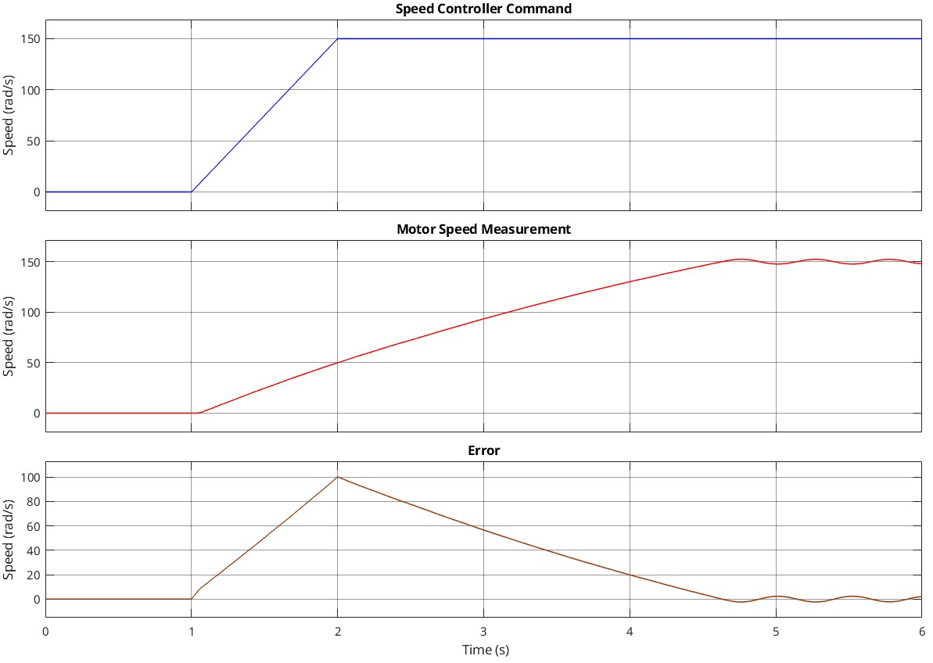

Figure x: Speed Controller Command, Measurement, and Error

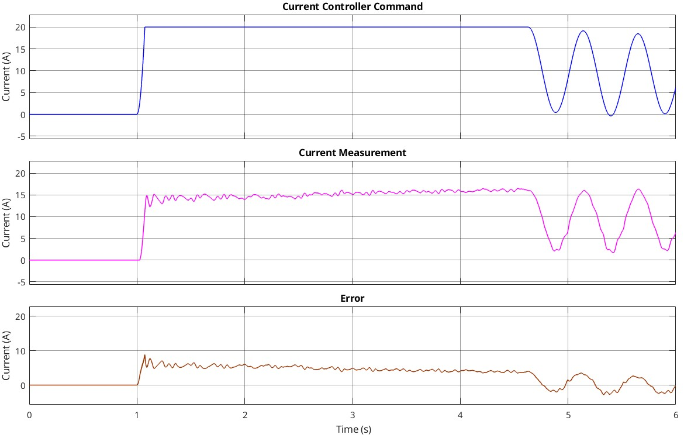

Figure x: Current Controller Command, Measurement, and Error

# Generator Model

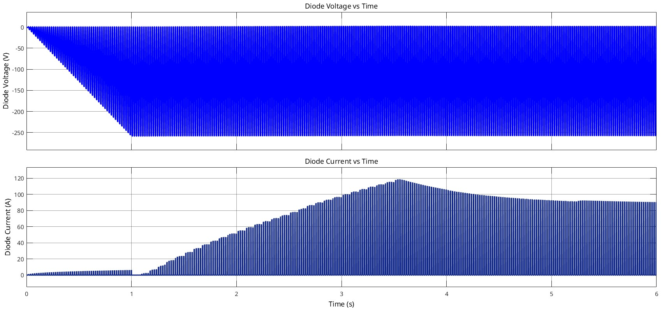

Figure x: Voltage and Current on the Diode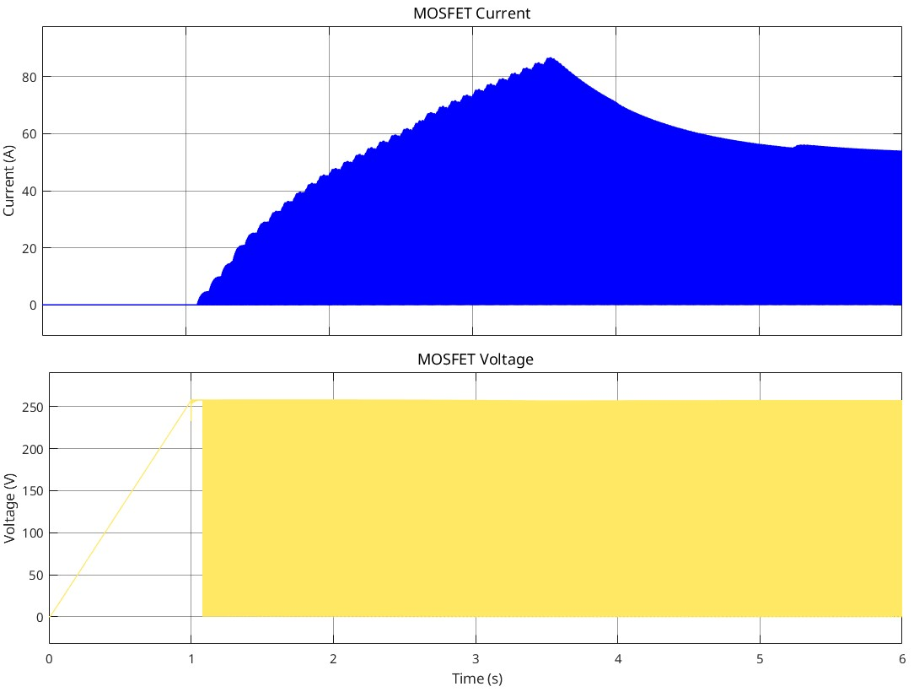

Figure x: Voltage and Current on the MOSFET

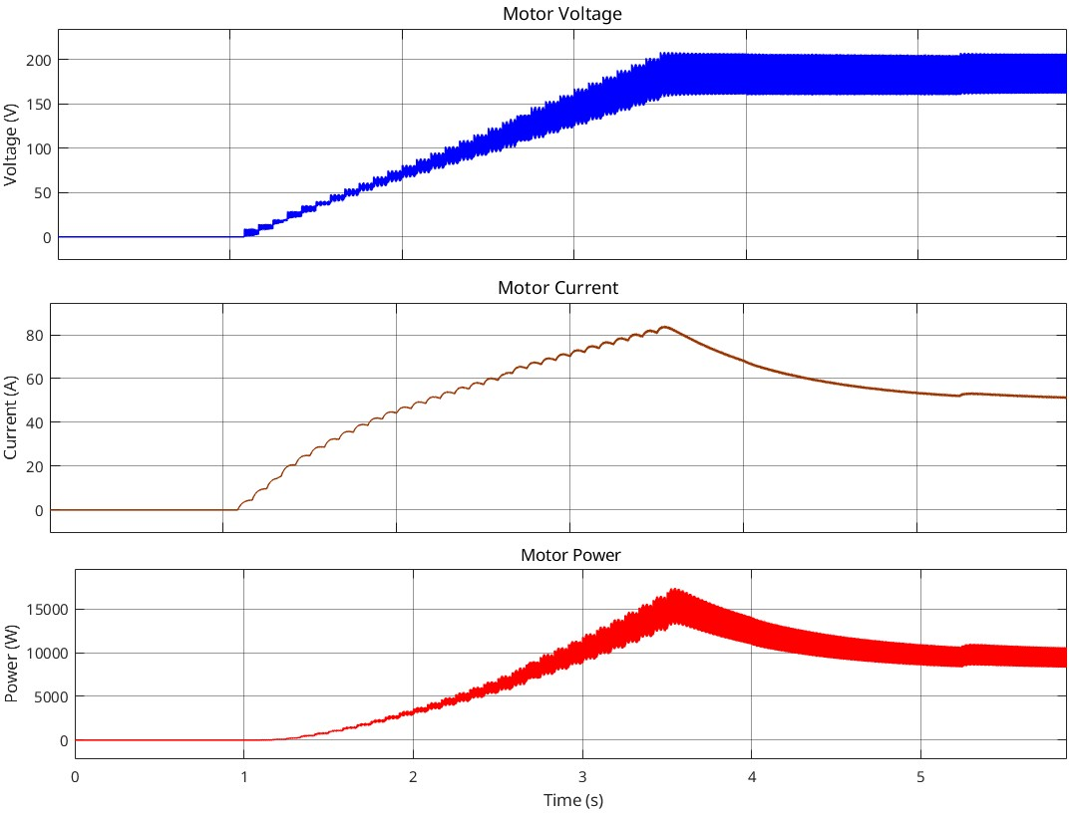

Figure x: Voltage, Current, and Power of the Motor

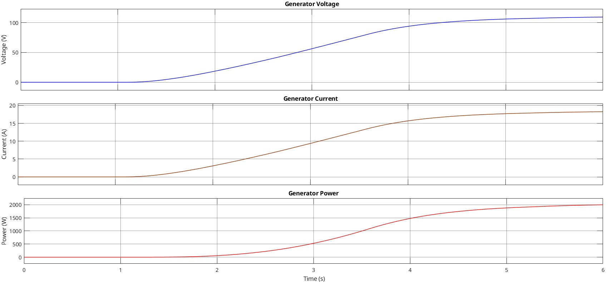

Figure x: Voltage, Current, and Power of the Generator

(motor current is not limited in this model however since the current rating of the motor is 23A this current should be limited which will cause output power to be even less. Furthermore diode mosfet currents will be more realizable like in the speed controller. Due to assumed parameters in motor and generator the loss is great and only 2kW can be generated from 10kW)

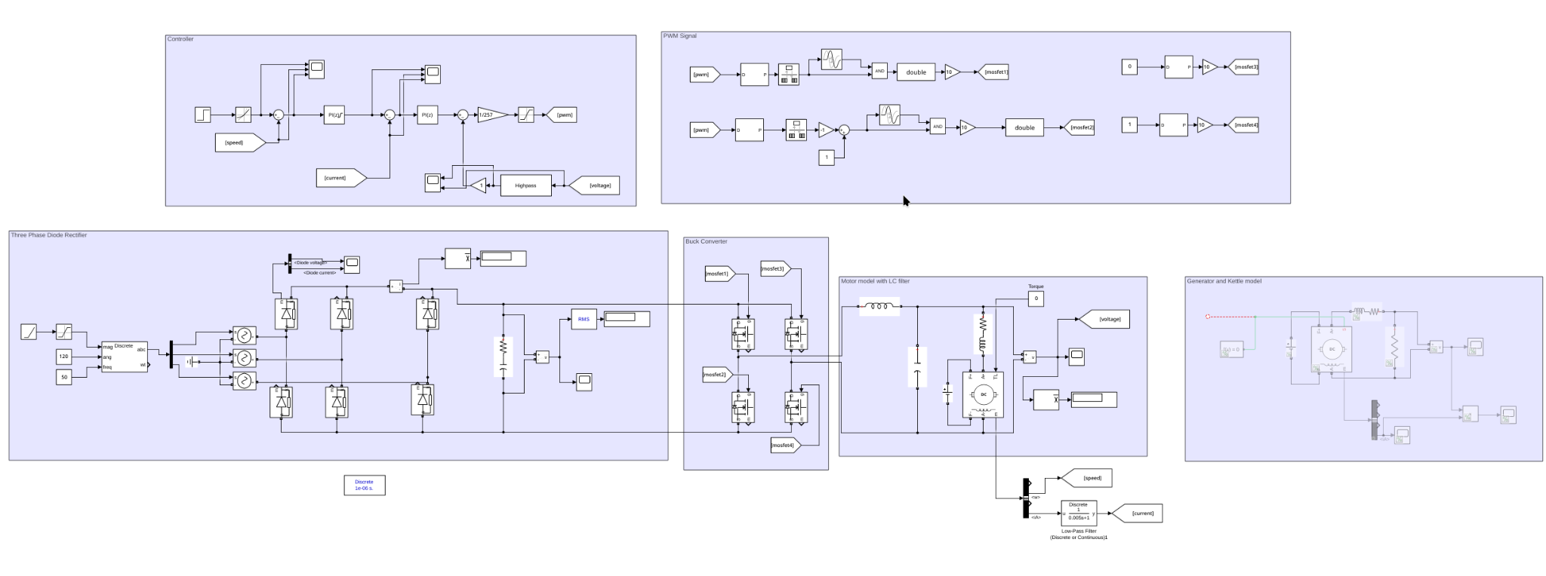

Figure x: Simulation Model for Speed Control

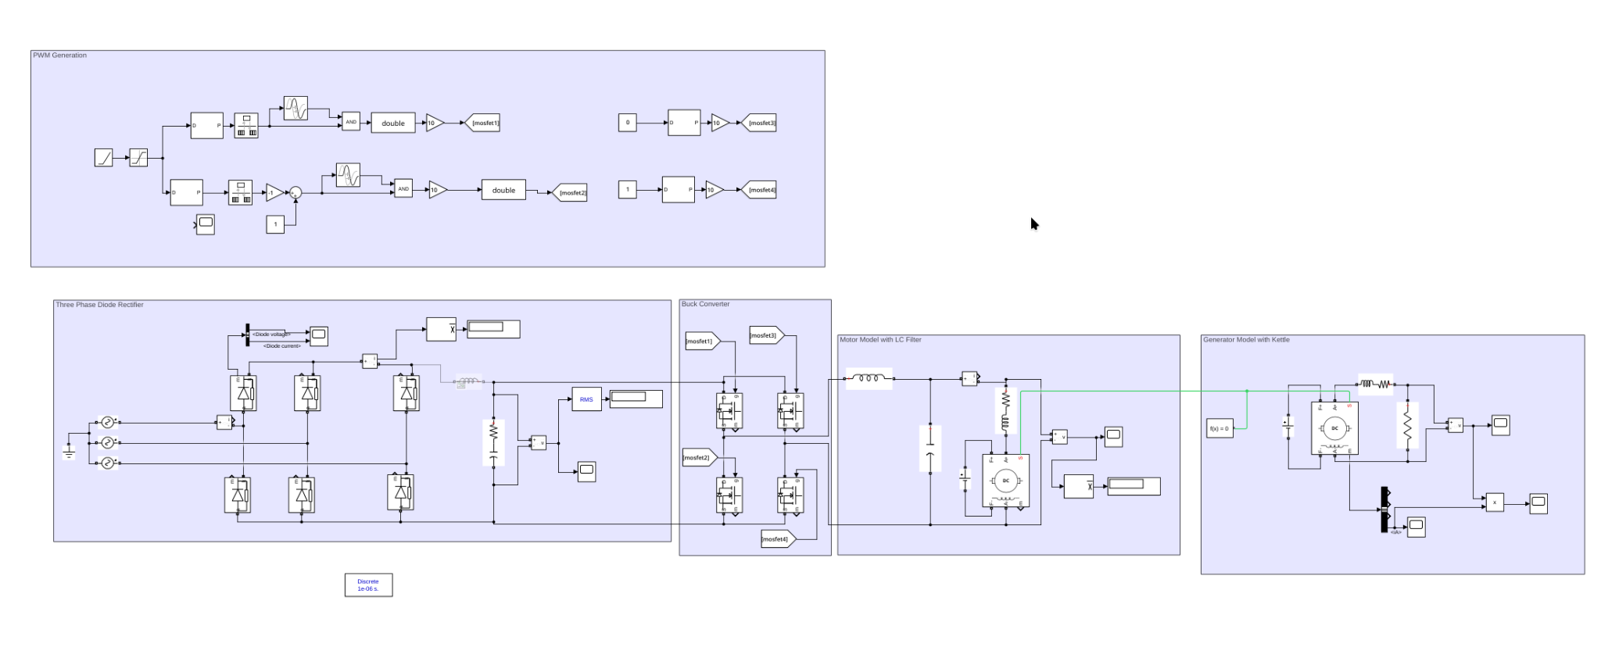

Figure x: Simulation Model for Generator